 | Ramaiah Medical College  Department of Library & Information Centre  MSR Nagar, MSRIT Post, Bangalore – 560 054  Tel: 080-2360 5190 / 2360 5408 /2360 6213 Extn. 203

CENTRAL LIBRARY STAFF
SL.  NO | NAME OF THE STAFF  (DESIGNATION ,E-MAIL ADDRESS & PHONE NO) | DATE OF JOINING | QUALIFICATION | PHOTO
 | Dr. Roopakala, M.S.  Professor In-charge of library | 02/05/1996 | M.B.B.S . M.D In Physiology | 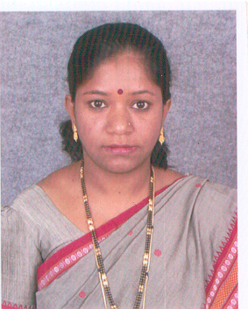
01 | Mr. Yethiraju B N  Assistant Librarian  e-mail:yraju22@yahoo.co.in  yraju22@gmail.com | 02/05/2003 | B.Sc.B.L.I.Sc  M,LISc. M.Phil | 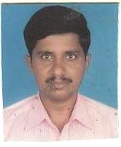
02 | Mr. Pramod B  Assistant Librarian  e-mail:pramodhbabu@gmail.com | 01/08/2005 | B.com, MLISc.  M.Phil. | 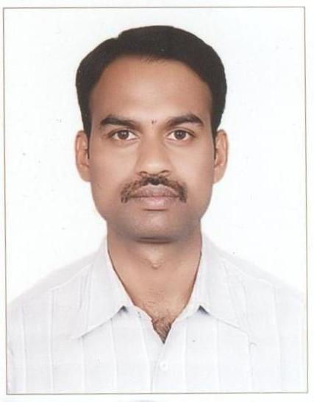
03 | Mr. Ananda V  Assistant Librarian  anandvbangalore@yahoo.co.in  anandvbangalore@gmail.com | 15/12/2005 | BA, MLISc.  M.Phil | 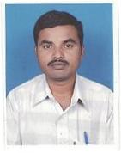
04 | Mr. Vijayakumar S  Library Assistant  e-mail: vijayagy@gmail.com  vijayagy@yahoo.co.in | 19/01/2009 | B.A. BEd, MLISc,  M.Phil  PGDC.HRM | 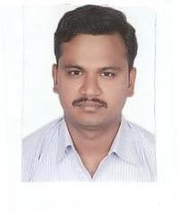
05 | Mr. Mohana K.B  Library Assistant  email: mohankbmsr@gmail.com | 18-04-2011 | B.A. BLISc,  MLISc | 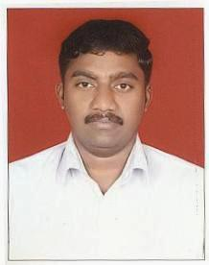
06 | Mr.Bharath S.N  Library Assistant  email: bharathsnmlisc@gmail.com | 27-08-2018 | B.A. MLISc | 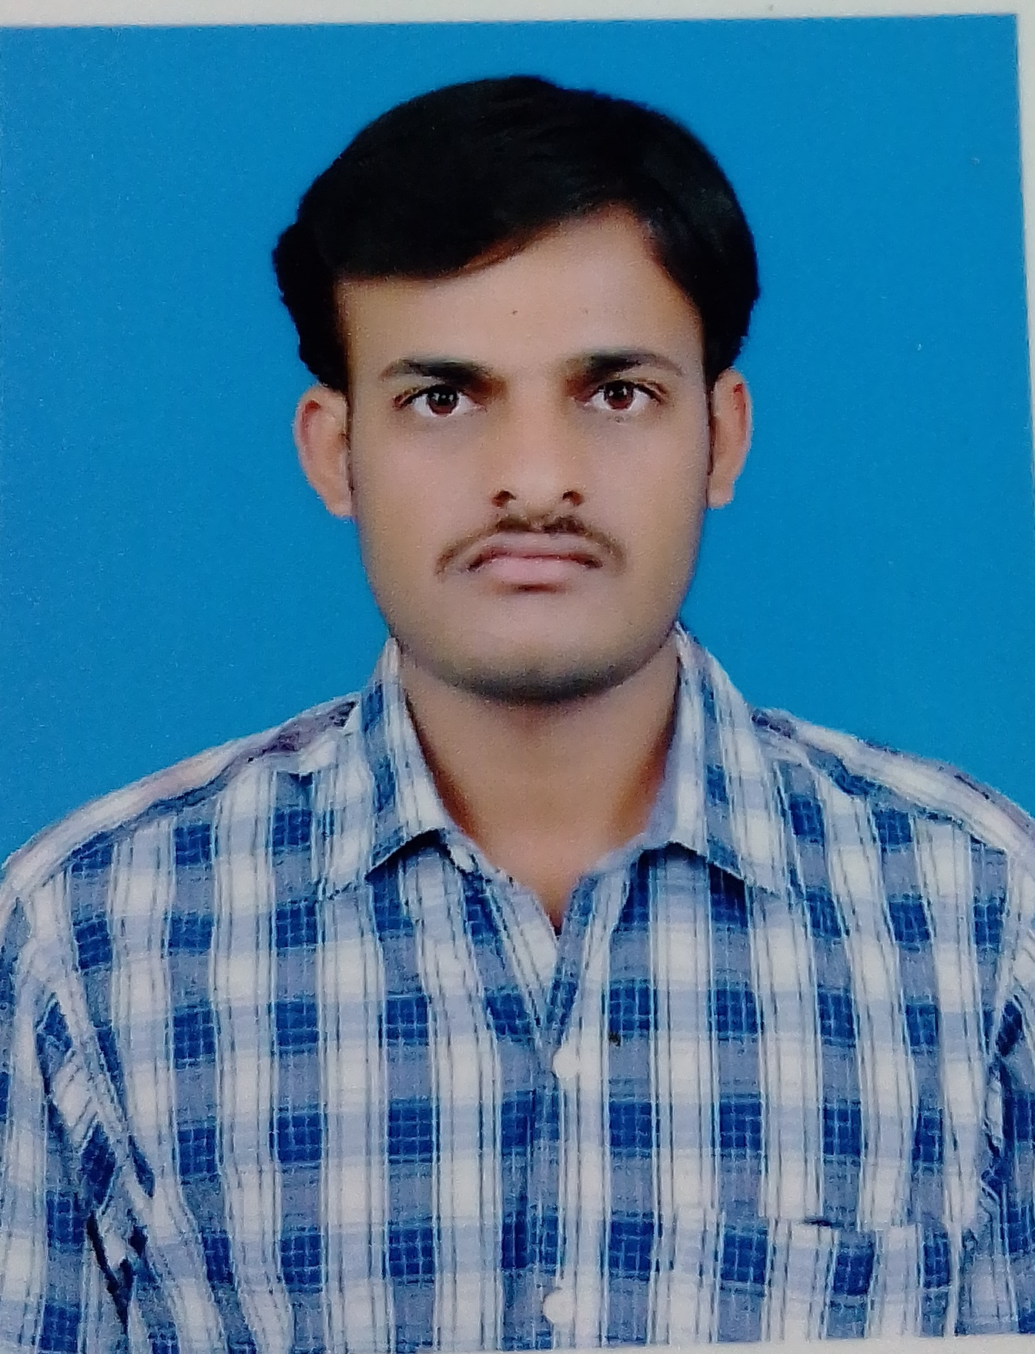
07 | Mr. H. Narayana  7th Standard  Attender | 02-01-1980 | 7th Standard | 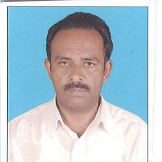
08 | M.P Srinivas  Office Assistant | 11-03-1991 | PUC | 

