E-Resources @ RMC

Subscribed / open access
URL LINK: https://www.clinicalkey.com/#!/ | IP authenticated Accessible in RMC COLLGE AND HOSPITAL.  Contact RMC library for Login Credentials.
URL LINK: https://www.scopus.com/search/form.uri?display=basic#basic | IP authenticated Accessible at RMC COLLGE AND HOSPITAL.  Scopus is the largest abstract and citation database of peer-reviewed literature: scientific journals, books and conference proceedings.
URL LINK: https://www.uptodate.com/contents/search | IP authenticated Accessible at RMC COLLGE AND HOSPITAL.  UpToDate is a subscription-based resource designed to provide physicians access to current clinical information. It addresses specific clinical issues in the form of topic reviews.
E- JOURNALS

URL LINK: https://www.sciencedirect.com/ | URL LINK: http://www.tandfonline.com
URL LINK :  https://www.wileyindia.com/Wiley_Online_Resources/HELINET/RGUHS-HELINET%20Consortium.html | URL LINK : https://www.proquest.com/index
URL LINK: https://www.cochranelibrary.com/ | URL LINK: https://ovidsp.dc2.ovid.com/ovid-b/ovidweb.cgi
URL LINK: https://www.jaypeedigital.com/home | URL LINK: https://www.bmj.com/
URL LINK: http://www.freemedicaljournals.com/ | URL LINK: https://doaj.org/search/journals?source

E-BOOKS

URL LINK: http://www.link.springer.com | URL LINK : https://www.proquest.com/index
URL : https://www.sciencedirect.com | URL LINK: https://www.jaypeedigital.com/home
URL : https://www.free-ebooks.net/medical-academic | URL : https://www.doabooks.org/

MASSIVE OPEN ONLINE COURSES
SWAYAM : Online learning courses URL:  URL :https://swayam.gov.in | National Programme on Technology Enhanced Learning  URL: https://nptel.ac.in/
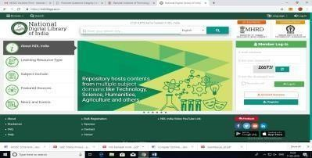  National Digital Library URL:https://ndl.iitkgp.ac.in/ | e-PG Pathshala  URL LINK: https://epgp.inflibnet.ac.in/
E-soudhasindhu  URL :https://ess.inflibnet.ac.in/ | 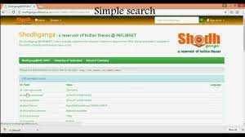  Shodhganga@INFLIBNET Centre  URL : https://shodhganga.inflibnet.ac.in/

M.S. RAMAIAH MEDICAL COLLEGE, M S Ramaiah Nagar, MSRIT Post, Bangalore 560 054 Tel: 080-2360 5190/1742 /1743 /5408. Fax: 080-2360 6213, Email:www.msrmc.ac.in, www.ramaiah- india.org

